**STUDENT LOANS 101**

[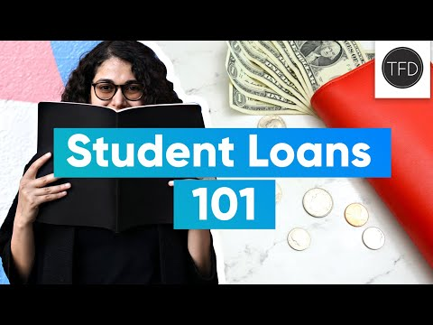](https://www.youtube.com/watch?v=FyLRxU5mJPM)